Experiment 11: Installation of Type-2 Hypervisor and VM Creation
Aim
To demonstrate virtualization by installing a Type-2 Hypervisor (Oracle VirtualBox) and creating a Virtual Machine with a Host Operating System (Windows/Linux).
Steps
- Download Oracle VirtualBox from the official website.
- Install VirtualBox by following the installation wizard.
- Launch VirtualBox after installation.
- Click New to create a new Virtual Machine.
- Enter the VM name and select OS type (Windows/Linux).
- Choose the version of the operating system.
- Proceed with default or custom settings.
- Attach the OS ISO file when prompted.
- Complete the VM creation process.
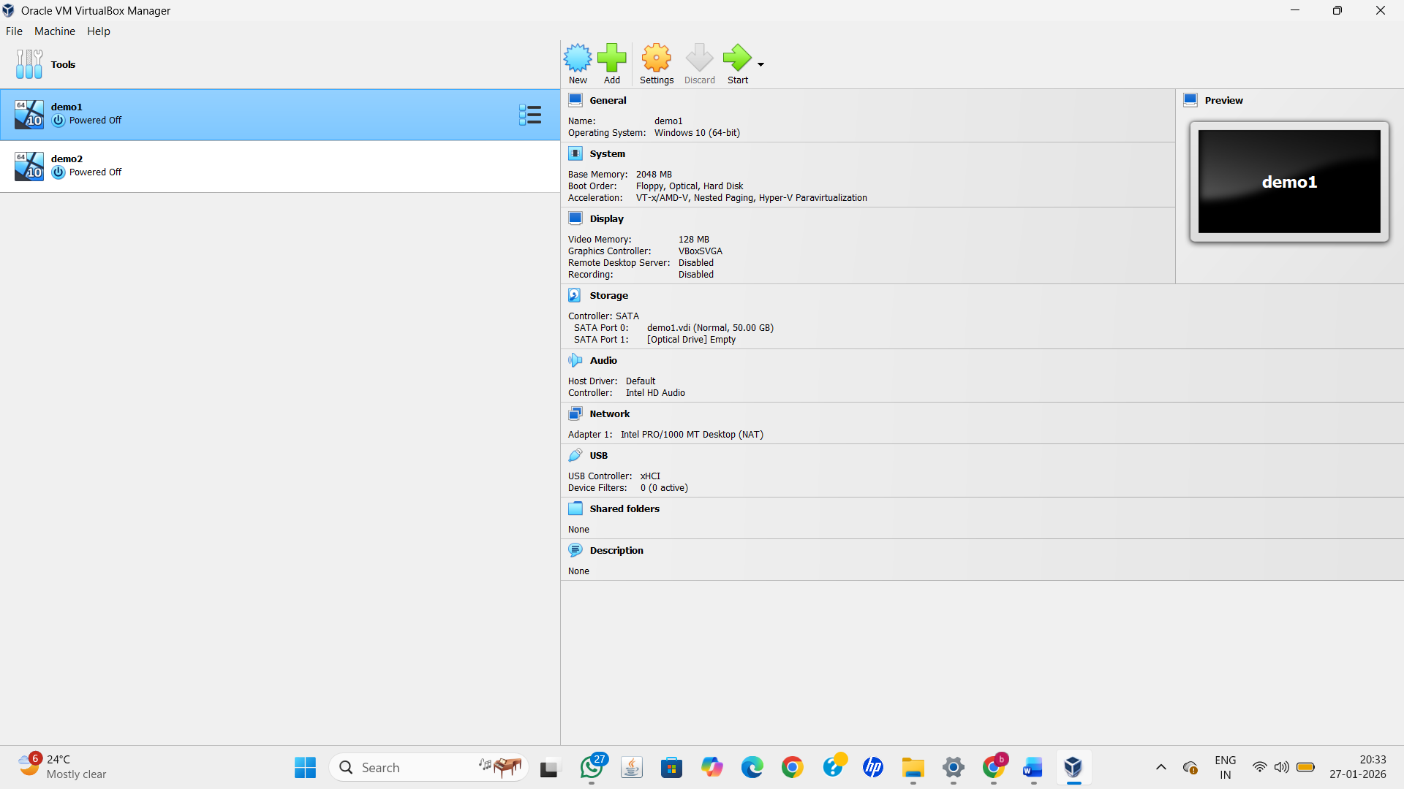
Result
Successfully installed VirtualBox Type-2 Hypervisor and created a Virtual Machine with a selected Host Operating System.

